ASSIGNMENT 7-Decision Tree

Mahima V PES1201700665

Amrita hegde PES1201700970

Chaitra H P PES1201701370

Problem Statement:

Construct a decision tree on a dataset.

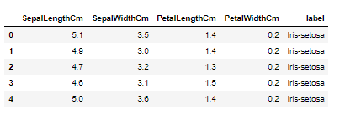

{'PetalWidthCm <= 0.8': ['Iris-setosa',

{'PetalWidthCm <= 1.65': [{'PetalLengthCm <= 4.95': ['Iris-versicolor',

'Iris-virginica']},

'Iris-virginica']}]}

